WAGE Competency Curriculum Guide

WAGE Competency M15: Converting fractions to decimals, percents to fractions, fractions to percents, percents to decimals, common fractions or mixed numbers to decimal fractions and decimal fractions to common fractions or mixed numbers to complete a task or subtask.

NOTE: You will need to collect two additional documents that are similar in nature to the one provided in this lesson at Hook 1a. These should be collected from local employers that support your program. These two additional documents will be used in Hooks 2 and 3 and are not to be duplicates of the other two documents used in this lesson. DO NOT USE MATERIALS THAT ARE NOT RELEVANT TO THE WORKPLACE.

Hook 1a
In order to perform most jobs in today’s work environment, all employees must be able to perform and understand the concepts of converting fractions, decimals, and percents, to equivalent forms. This is also true for completing numerous household functions as well. When you buy or sell fro yourself, family, or others, you must be able to understand the basic concepts related to converting these numbers to the equivalent forms. This will result in any organization, or family unit, running more efficiently and effectively. The final result will be an increase in profits and savings for everyone. Large or small errors in recognizing increases or decreases in percents could cause any organization or family to lose large sums of money. This is why it is very important to know how to convert fractions, decimals, and percents correctly
Project overhead transparencies of: “Percent”, pages 57 and 58. Take these from Contemporary’s Number Power, Advanced. Also, provide each student with a hard copy of each transparency to use as they follow along. Give them a scenario that will require them to use the concepts of conversion. Let’s assume that you have just finished an interview for a position with Regions Bank. Then you are given these worksheets to complete before being hired. You have one hour to complete the assignment and then a decision will be made. After one hour, give out the answers and have each student check their work. Record all the scores on the chalkboard and save these results for later use.
It is imperative that you maintain at least a ten percent profit margin on all sales”. Each student is to be given the worksheets and told they have one hour to complete both of the worksheets. After one hour, (or sooner if you see everyone has finished) give out the answers and have each student check their work. Record all the answers on the chalkboard and save these results for use at a later time.

Bridge
Acknowledge and praise the highest scores and emphasize that often the people with the best scores on these type performance tests are the ones that are hired. Then say, “Now we are going to our lessons and find out what the rules and the steps to follow are for each worksheet. When we have finished we will return to our job application handouts and look at the score list again. All mistakes will be corrected to one hundred percent”.
Ask, “Do you believe there are important thinking steps that should be used when completing these problems?” Say, “List the thinking steps that you used to solve these problems”.
Book
Select a lesson (or lessons) from the wage curriculum Matrix or other source that best supports your needs. Spend ample time in the chosen lessons until you believe that each learner has mastered the skill. As you move through each lesson, be sure to emphasize the thinking steps that a learner must use to correctly apply this skill. Be sure and stress the importance of knowing these concepts for success on the job, and sometimes, for getting the position you want. These skills are also needed to successfully run a household, as well as, a business. Ensure that all thinking steps are properly sequenced during the learning and that each learner has had opportunities to practice each step in the application of the skill. Write the thinking steps identified by the lesson(s) in the sequential order they are to be used; you will use these again in Hooks 1b, 2, and 3.
Use lessons from the WAGE: Clerical Literacy Skills, Section 24, “Decimals and Percents”. The lessons are: “Changing Decimals and Fractions to Percents”, “Changing Percents to Decimals and Fractions”, and “Fraction, Decimal, and Percent Equivalents”. The other lessons will be selected from the Contemporary’s Number Power, Advanced. These lessons are titled: “Percent”, and “Skills Inventory Post-Test”.
Thinking Steps for Competency M14:
NOTE: I f your chosen lesson(s) indicates a different set of thinking than these listed here, substitute those that was presented in the lesson(s).

- Define your goal.
- Identify the rules and steps you need to know and follow.
- Identify the importance of knowing these concepts for job and family success.
- Clear up and review any rules, steps, or concepts you don’t understand.

Hook 1b
Example: Read and discuss the rules and steps needed to complete the handouts from WAGE: Clerical Literacy Skills, pages 24, 25, and 26. Also, include the handouts from Contemporary’s Number Power, Advanced, pages 57, 58, 137, and 138. Make sure the students have the handouts they completed for the Regions Bank scenario. Identify the rules and steps the students need to know and that all have a good understanding of the concepts involved.
Get out the handout: “Percent”. Remind the students about the job scenario for Regions Bank: also discuss the thinking steps an applicant must follow when taking a test for a job on the concepts of converting fractions, decimals, and percents. Say, “Do you remember when I asked you to tell me the thinking steps an applicant or employee must follow when taking a test for a job or better position? Let’s review the steps you came up with and I’ll post them on the chalkboard.” Also, post the scores from the handouts on the chalkboard. Ask, “Who do you think will be selected for this new position?”
Call out each thinking step and include the rules and steps for each task. Get the learners to assist you as you practice each step for all the lessons. Understanding the rules and steps is crucial for success in converting fractions, decimals, and percents. Review other lessons on the basic concepts of each, if the students demonstrate a lack of knowledge in these areas. A good foundation is necessary for success in grasping these new concepts.

Hook 2
Say, “Now that we have reviewed the rules and used them in a work related setting, are there any questions before we start two more job related scenarios with these math concepts?” Address all concerns before moving on.
Have the students get their copy of the handout “Changing Decimals and Fractions to Percents” and “Changing Percents to Decimals and Fractions”. Say, “These exercises will use the same concepts as covered in the first scenario. On these lessons, I want you to work alone and use the same thinking steps you learned earlier, as I will ask each of you to go through each step. Are there any questions about your assignment?”
When all finished, have volunteers explain the thinking steps and the rules used to complete these assignments. Pay attention to the proper sequence, the learner’s ability to perform each problem correctly, and the actions that must take place at each step. Correct all problems, if necessary, and then address any questions the learners may have.
NOTE: Mastery of this competency is determined by the students’ work on Hook 2. Review or rework is necessary when a student has not demonstrated mastery at Hook 2. Mastery is defined as the task being performed correctly with zero mistakes. A WAGE certificate should not be granted without mastery on all competencies listed in the student’s Individualized Program Plan.

Hook 3
Compliment the class for all the good work done at Hook 2. Praise builds confidence and helps the students feel positive about the tasks they have completed. Say, “For this last exercise, you will work in teams, like they do at the workplace. Teamwork is crucial for the success of all companies, organizations, small businesses, or even households. In the workplace, good supervisors know that people who are working together usually do the best work. Through teamwork, the goals of the organization can be better accomplished.
“Now, I want you to move into teams of at least three people and no more than five people. Your team will need a leader, so select a leader now.” The team leader will be responsible for submitting the final product as fast and accurate as possible. Make note of the leader in each team. Try to see that all learners have an opportunity to serve as leader during the course of their study.
Give each team a set of handouts: “Fraction, Decimal, and Percent Equivalents”, page 26 and “Skills Inventory Post-Test”, pages 137 and 138 from Contemporary’s Number Power, Advanced. Have them focus on the decimal, fractions, and percent skill areas. Give them this scenario; the Regions Bank was impressed with all the applicants. However, they need a special team to perform updates and improve their Home Mortgage Department. Since everyone scored so well on the first part of the hiring process, this exercise will be the tiebreaker to determine which team is selected for this new project. The winning team must be able to convert fractions, decimals, and percents quickly and accurately. Then, still working as a team, complete the “Skills Inventory Post-Test”. The team that can complete these two handouts in the fastest time with the fewest errors will be hired for this new department. When all the team members have completed their tasks, the team leader will provide the completed handouts to the instructor.
The instructor will record the time each team is finished. Ten minutes will be added to the time for each incorrect answer. Remind the students that accuracy is very important any mistakes could cost all the team members the job in this new position. The winning team will be rewarded with a new position paying twenty dollars an hour, with all benefits. The losing teams will be offered part-time positions, with no benefits, no paid vacations or holidays and making only fifteen dollars an hour. So, good teamwork is critical.
After all handouts are turned in and the scores tabulated, the winning team will have the team leader explain the thinking steps they used, the procedures they followed, and the rules they needed to know to finish first. Discuss the importance of teamwork in meeting deadlines. Stress the importance of accuracy and speed. Remind all the students of the determining the rate of increase and decrease.
NOTE: When it is impossible to use teams at Hook 3, usually due to an open-entry, open-exit class format, you will want to use peer tutors, paraprofessionals, or yourself as a supplement to the team. When conducted correctly, the concepts of interdependence can be reinforced when there are only two people assigned to the task.
Evaluation for M14:
Score at lease 85% or higher on all the worksheets given out to complete.

On the team exercise, score 100% (correct as needed) on the worksheets given out to complete.

Be able to discuss the importance of teamwork in the workplace and the ability to do work quickly and accurately.

Resource Listing for M13:
Contemporary’s Number Power, Advanced; Edition Level A. Contemporary Books, Chicago. 1999.
WAGE: Clerical Literacy Skill: Section 24, Decimals and Percents, Revision One. January/1998. Pulaski County Special School District.

Copyright © by Pulaski County Special School District Adult Education WAGE Training Program
No part of this curriculum may be reproduced in whole or in part, stored in a retrieval system, or transmitted in any form or by any means, electronic, mechanical, photocopying, recording or otherwise, without written permission from WAGE Training Program.
For permission information contact: WAGE Training Program, 4300 Haywood, North Little Rock, AR 72114.

Name _________________________________ Date ________________

Percent
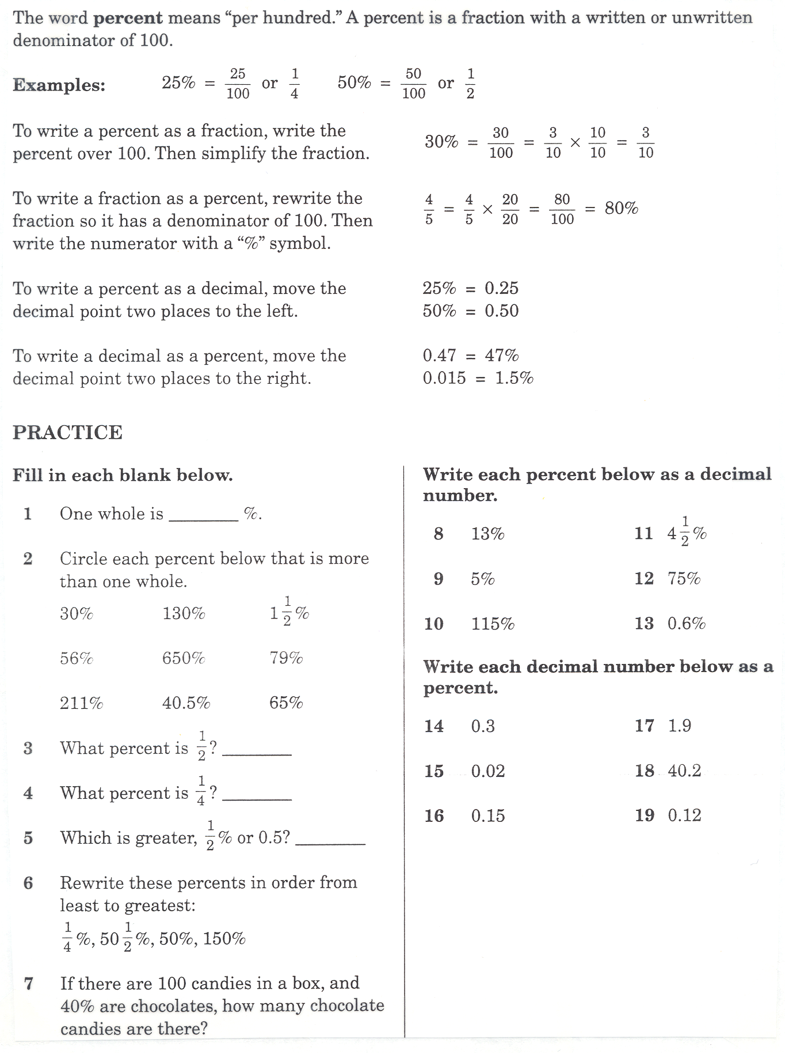

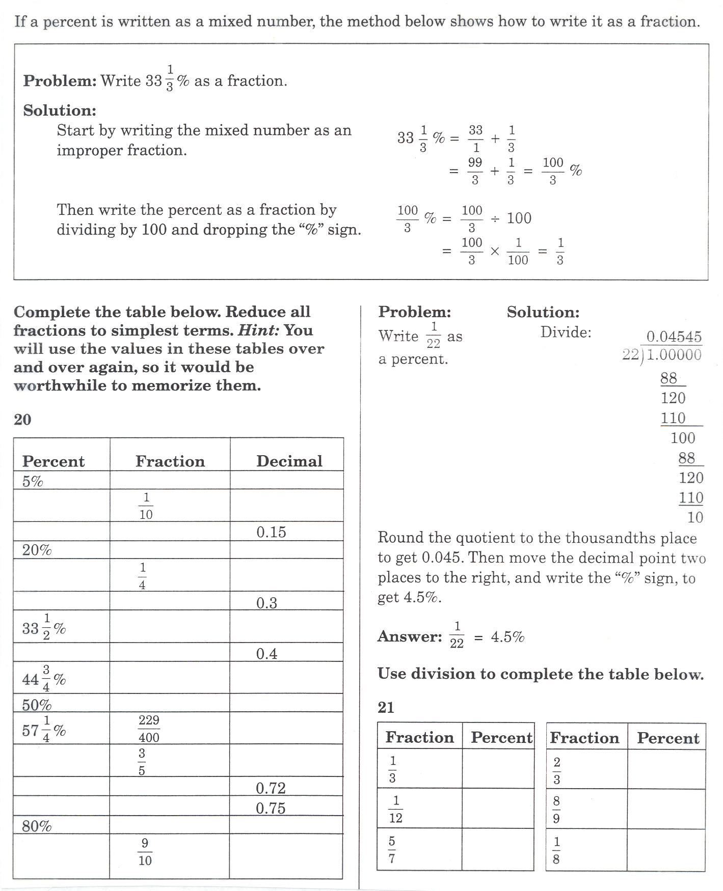
Percent Con’t

Name _________________________________ Date ________________

Changing Decimals and Fractions to Percents
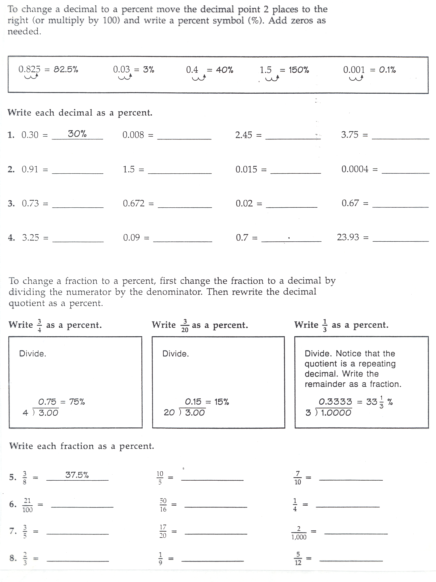

Name __________________________________ Date _______________

Changing Percents to Decimals and Fractions
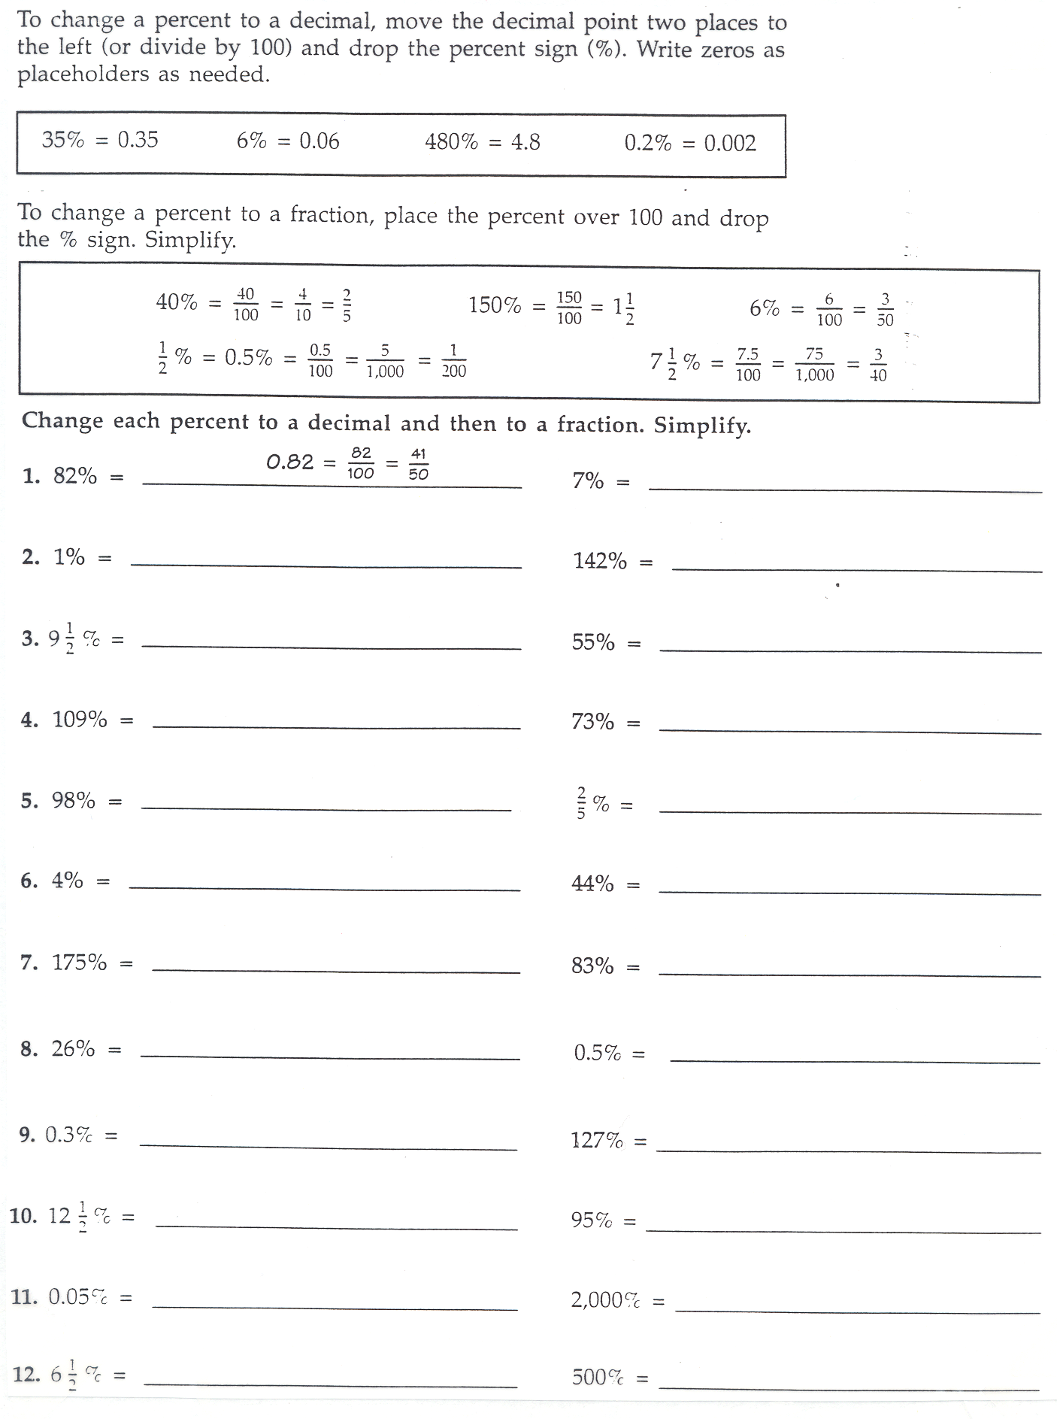

Name ________________________________ Date _________________

Fraction, Decimal, and Percent Equivalents
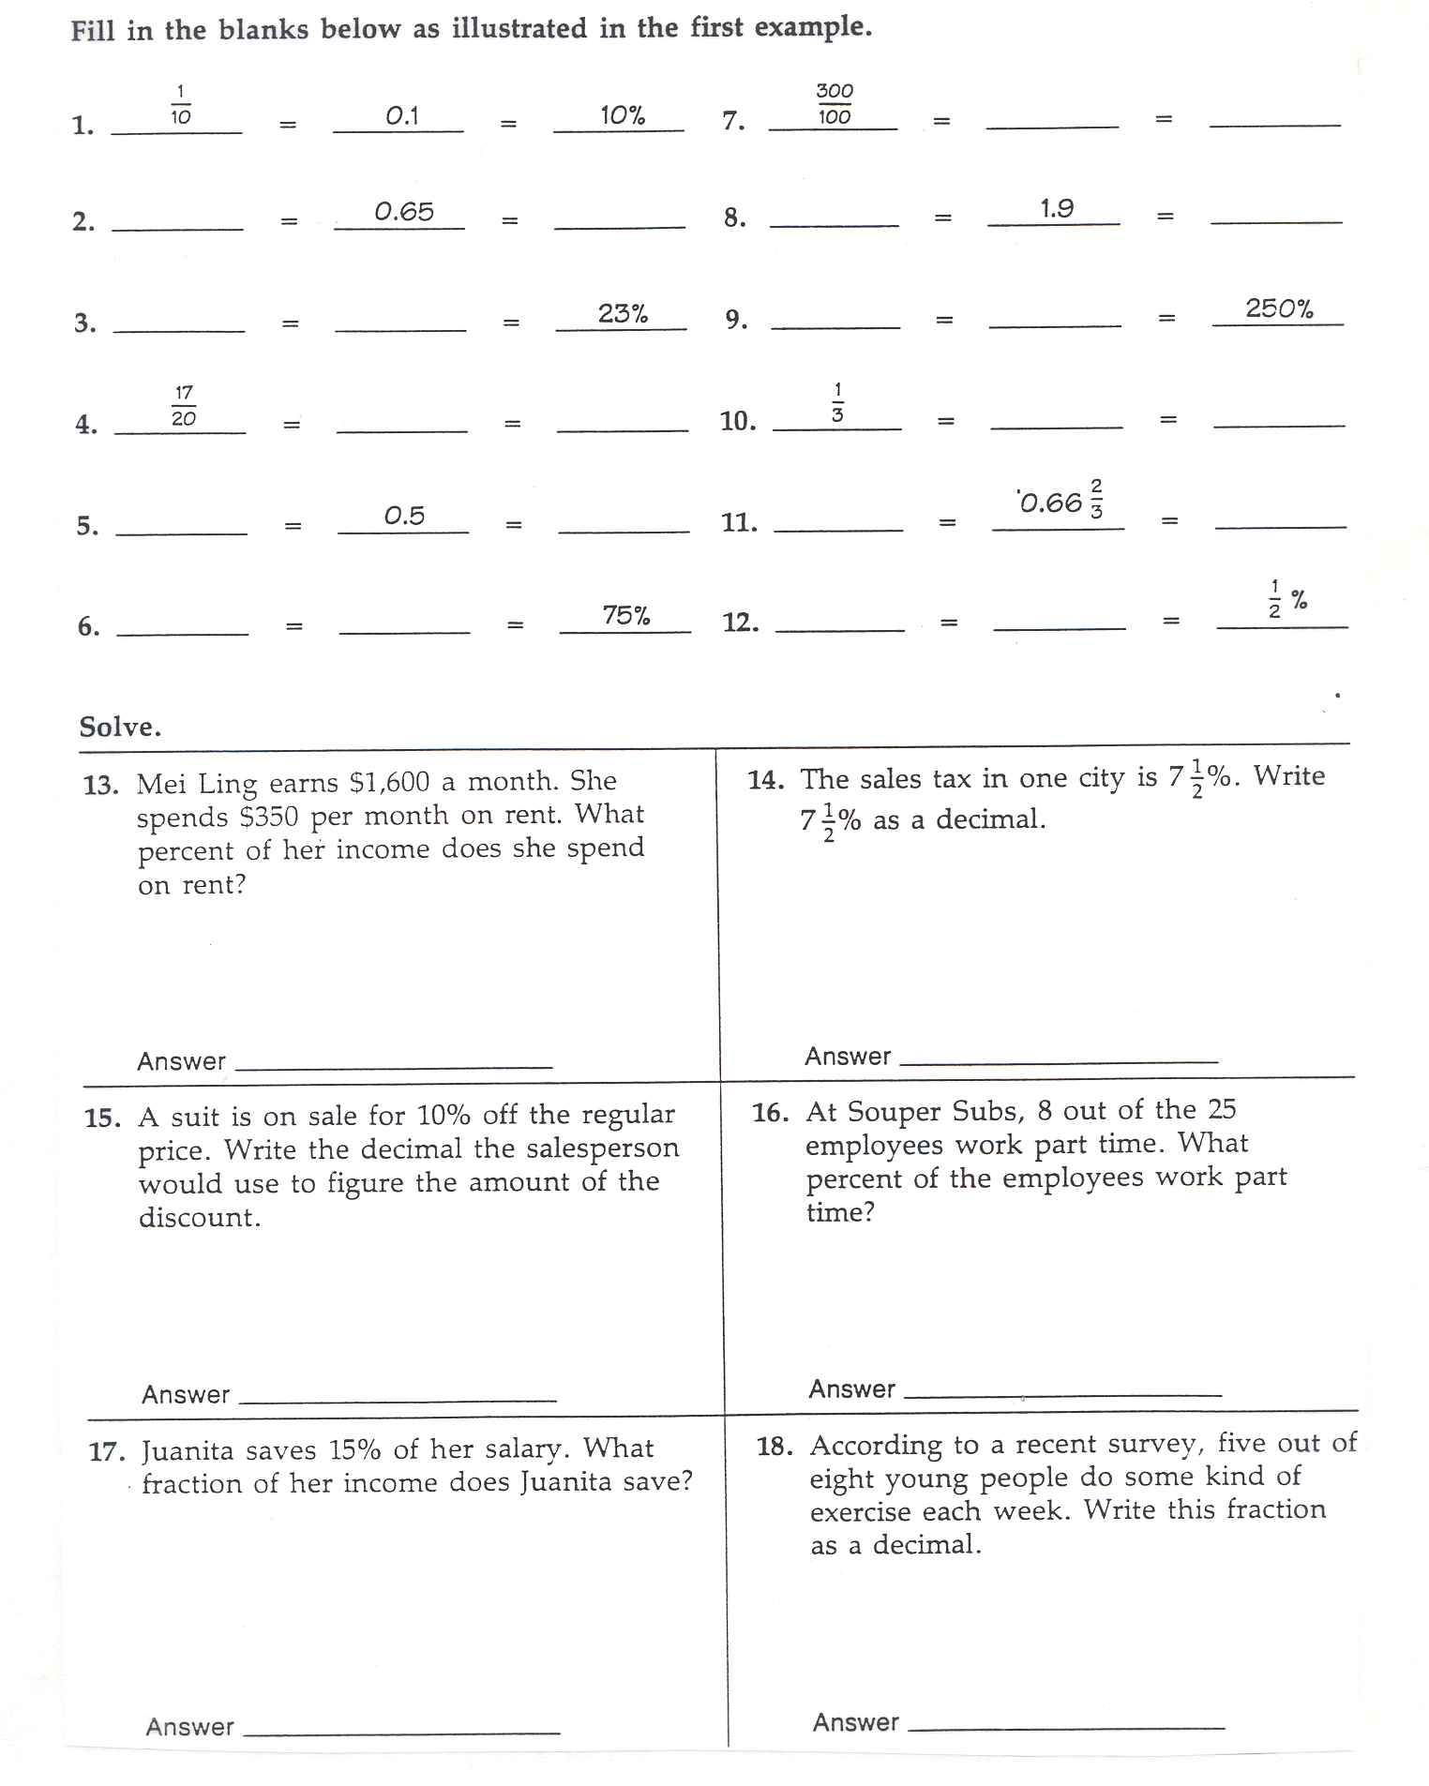

Name _________________________________ Date ________________

Skills Inventory Post-Test
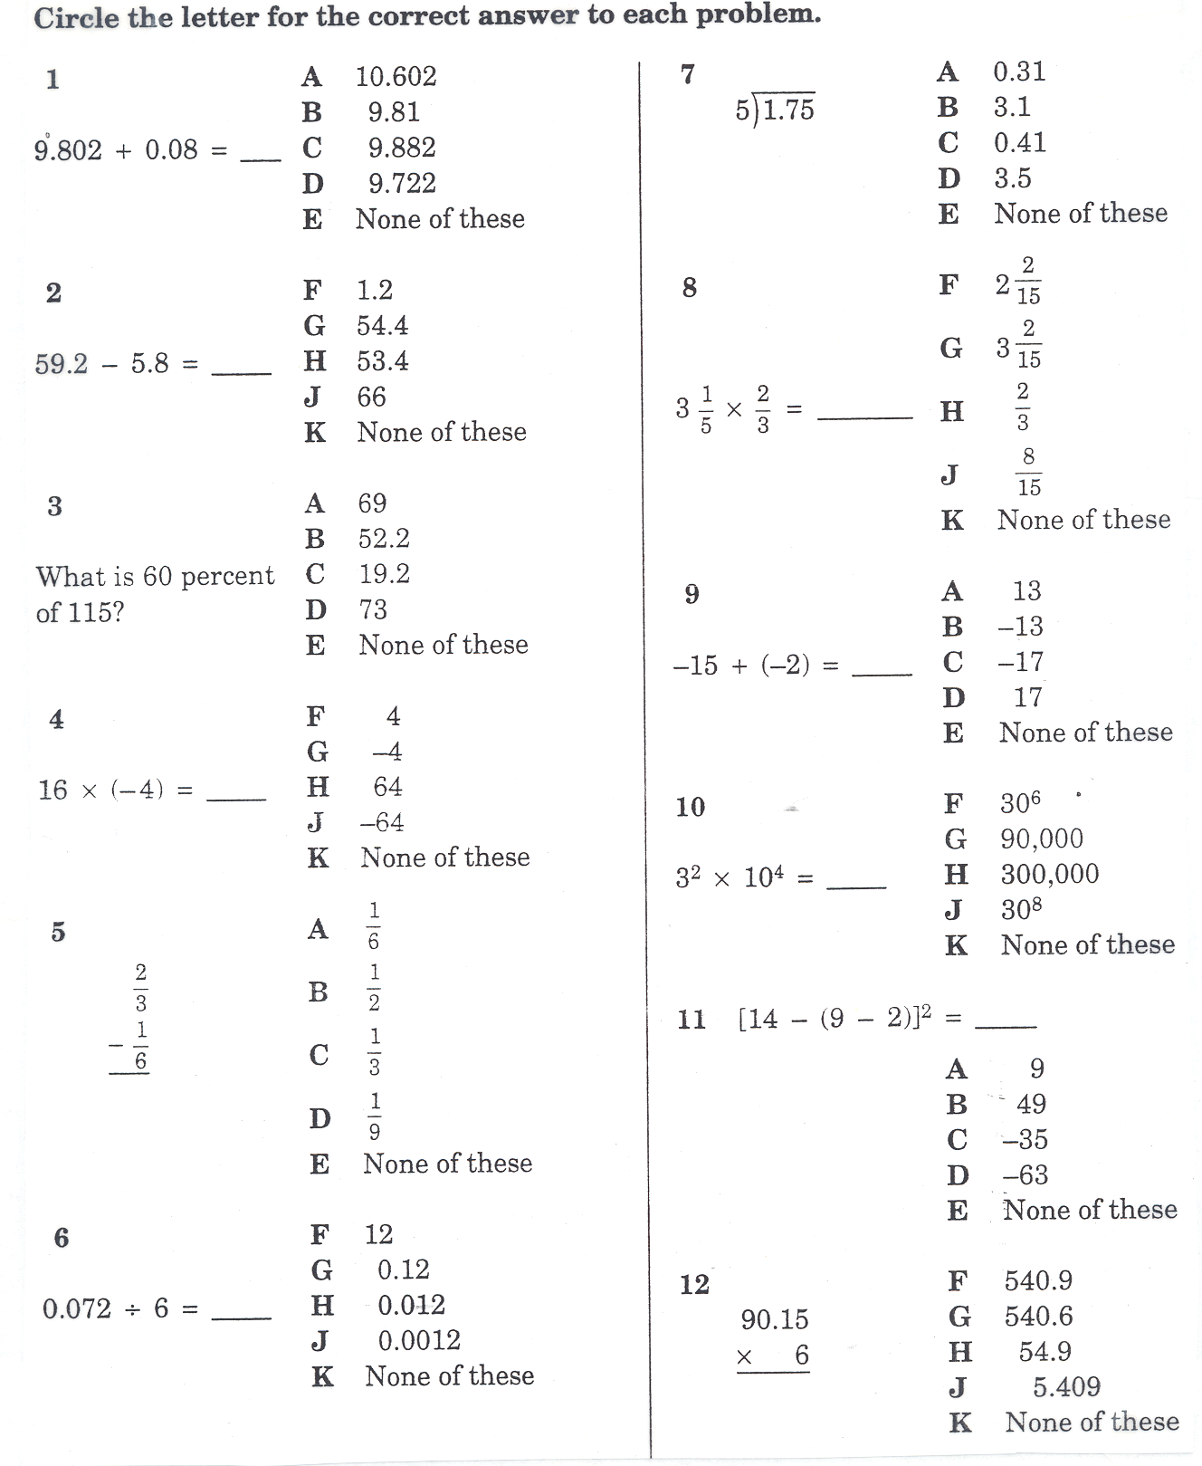

Post-test Con’t
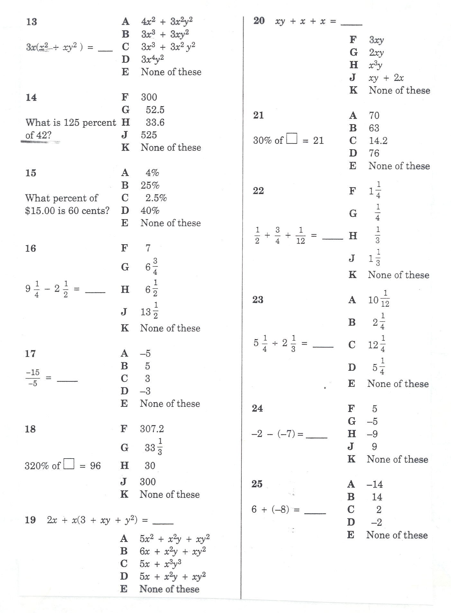

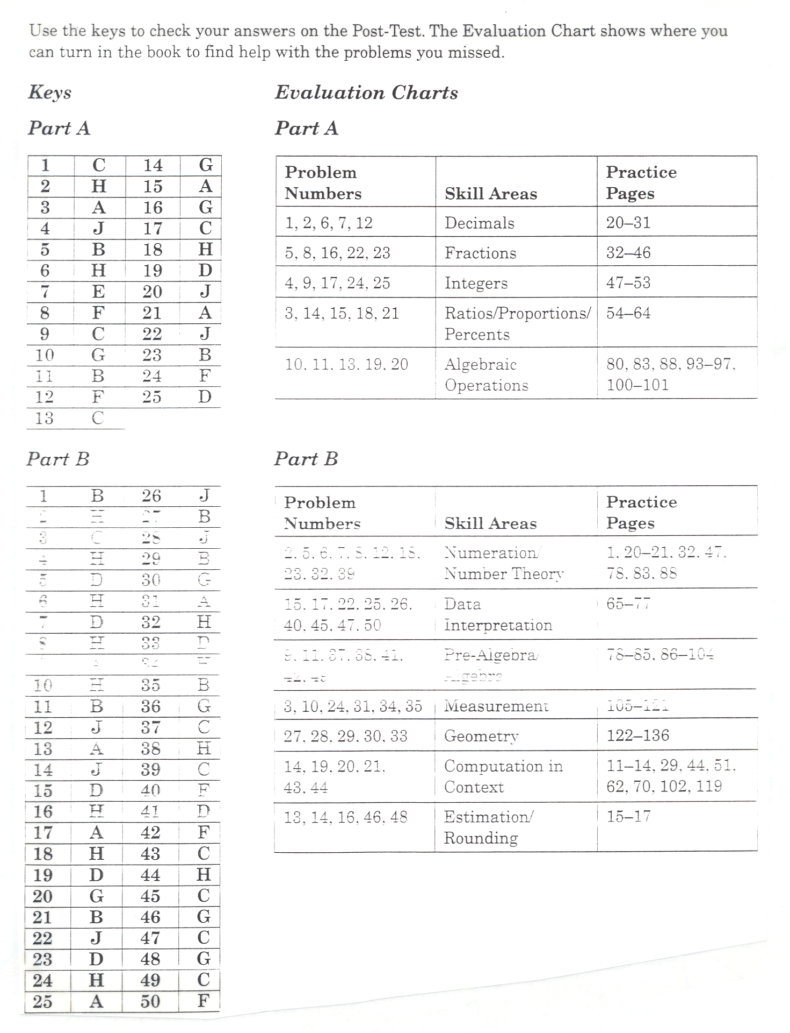
Skills Inventory Post-Test Evaluation Chart

